BIOLOGY – GENETICS AND EVOLUTION SUMMARY – YEAR 10 SCIENCE
DEFINITIONS:
Allele | A version of a gene eg: eye colour may have a brown allele and a blue allele
Haploid | Containing only half the normal number of chromosomes
Chromosome | Long, thread-like structures found in the nucleus , made up of genes
DNA | Deoxyribonucleic Acid – molecule that carries the genetic code or blueprint for making the organism
Dominant | The gene which determines the outcome, represented by a capital letter, it is always expressed in the phenotype
Pedigree Chart | ‘Family Tree’ which shows genetic information about how characteristics have been passed on through generations
Gene | A portion of a chromosome that codes for a particular characteristic or trait
Diploid | Has the full amount of chromosomes
Heterozygous | Having two different alleles - one dominant and one recessive allele for a trait (‘mixed’)
Homozygous | Having both the same type of allele for a trait, ie: either both dominant, or both recessive
Inheritance/Heredity | The process of genetic transmission of characteristics from parent or ancestor to offspring.
Genetics | The study of heredity, or how the characteristics of living things are transmitted from one generation to the next. The basic unit of heredity is the gene
Karyotype | A karyotype is a picture of the number and appearance of an individual’s chromosomes, and includes their length and banding pattern, usually displayed as pairs in descending order of size
Mutation | A change or abnormality in a gene or chromosome
Carrier | Another term for heterozygous or hybrid – has one dominant and one recessive allele for a characteristic
Punnett Square | Used to show the predicted outcomes of a genetic cross
Pure breeder | Homozygous genotype; has two of the same alleles for a characteristic
Recessive | The characteristic that is masked by a dominant allele; is only expressed if there is two recessive alleles
Sex-linked | The gene is carried on the X chromosome
Genotype | The letters that show what alleles an organism has, eg: BB or Bb or bb
Phenotype | The description of what the genotype means, eg: black hair, tongue roller, red flowers
Generation | Group of people born around the same time
XX | Female chromosomes
XY | Male chromosomes
Hybrid | Another word for heterozygous – has a dominant and a recessive allele
Gametes | Sex cells – sperm and eggs

DNA
- DNA stands for Deoxyribonucleic Acid
- It makes up the genetic code of the organism; it contains the instructions needed to determine the characteristics of an organsim
- It is a very long molecule that looks a bit like a twisted ladder called a double helix
- Base A (adenine) always joins up with Base T (thymine)
- Base C (cytosine) always joins up with Base G (guanine)
- So, if one side of the ladder has a base sequence of CAACGGTTT, then the other side will be GTTGCCAAA
SEX CELLS
- Sex cells are sperm and eggs.
- Another name for sex cells is gametes
- At fertilization the male and female sex cells will provide ½ of the chromosomes each – so the offspring has genes from both parents
- The new cell formed when a sperm joins an egg will have 23 chromosomes from the mother and 23 chromosomes from the father, thus resulting in 46 chromosomes in total
- If the gametes did not carry half the normal number of chromosomes, the offspring would end up with double the right amount!
MONOHYBRID CROSSES
- Genes come in pairs
  - One from the mother
  - One from the father
- Both genes contain instructions for the same trait (ex. Hair colour)
- Possible codes for a particular gene
- One allele may code for brown hair
- The other may code for blonde hair
- The dominant allele is always expressed
- A monohybrid cross is a mating between 2 organisms involving only 1 gene.
- It allows predictions to be made about the possible genetic make up of the offspring
- A punnett square is usually used to display the predicted results of a monohybrid cross
- The original organisms that are crossed are the parents.

Example:
Fuzzy hair on dogs is dominant over straight hair. Calculate the expected genotypes and phenotypes of the offspring that could be produced when a heterozygous fuzzy dog breeds with a straight haired dog.
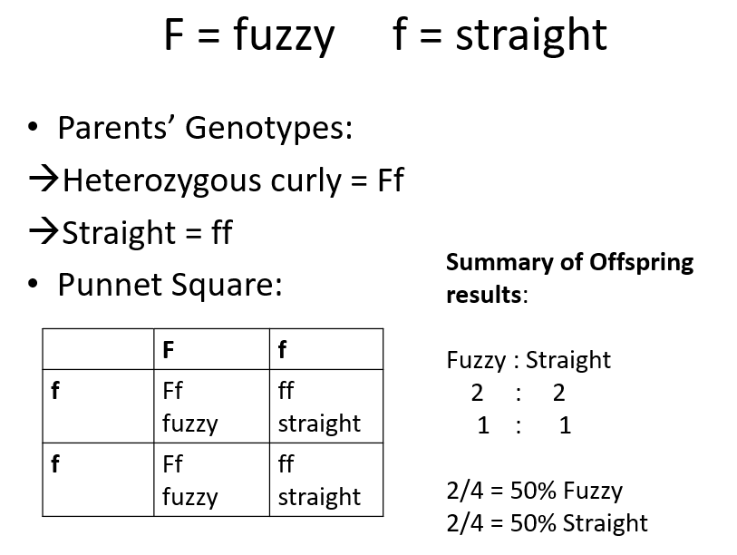

SEX LINKED CROSSES
- Humans have 23 pairs of chromosomes.
- One pair is responsible for determining the sex of the offspring.
- These chromosomes are called the sex chromosomes. There are two types - X and Y.
XX - Female
XY - Male
- Sperm cells can contain either a X or a Y chromosome, plus 22 others. Ova only contain X chromosomes, plus 22 others.
- All offspring get an X chromosome from their mother.
- It depends on which chromosome the father's sperm cell is carrying - X or Y - as to whether the baby is a boy or a girl.
- Certain characteristics in humans are linked to the sex chromosomes.
Sex linkage affects are seen mainly in males. The reason for this is that X and Y chromosomes are different sizes. There are a number of genes on the X chromosome that have no equivalent on the smaller Y chromosome, like colour vision and blood clotting.
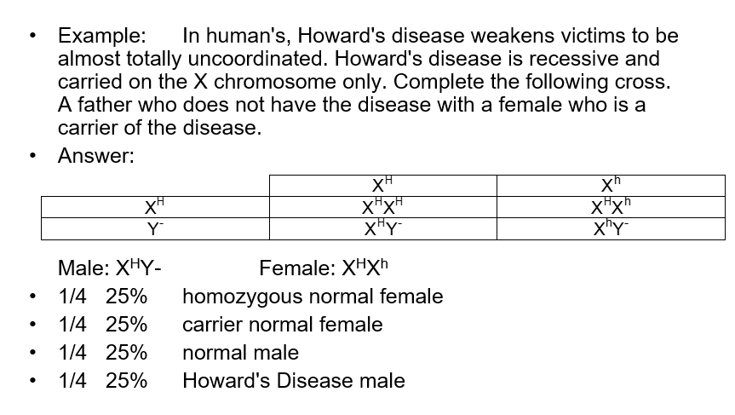
PEDIGREES
- Pedigrees are a type of family tree containing genetic information
- They are used to determine the genotypes of individuals in a family and to better determine the probability of a child getting a trait.
- Multiple generations are considered in pedigrees.
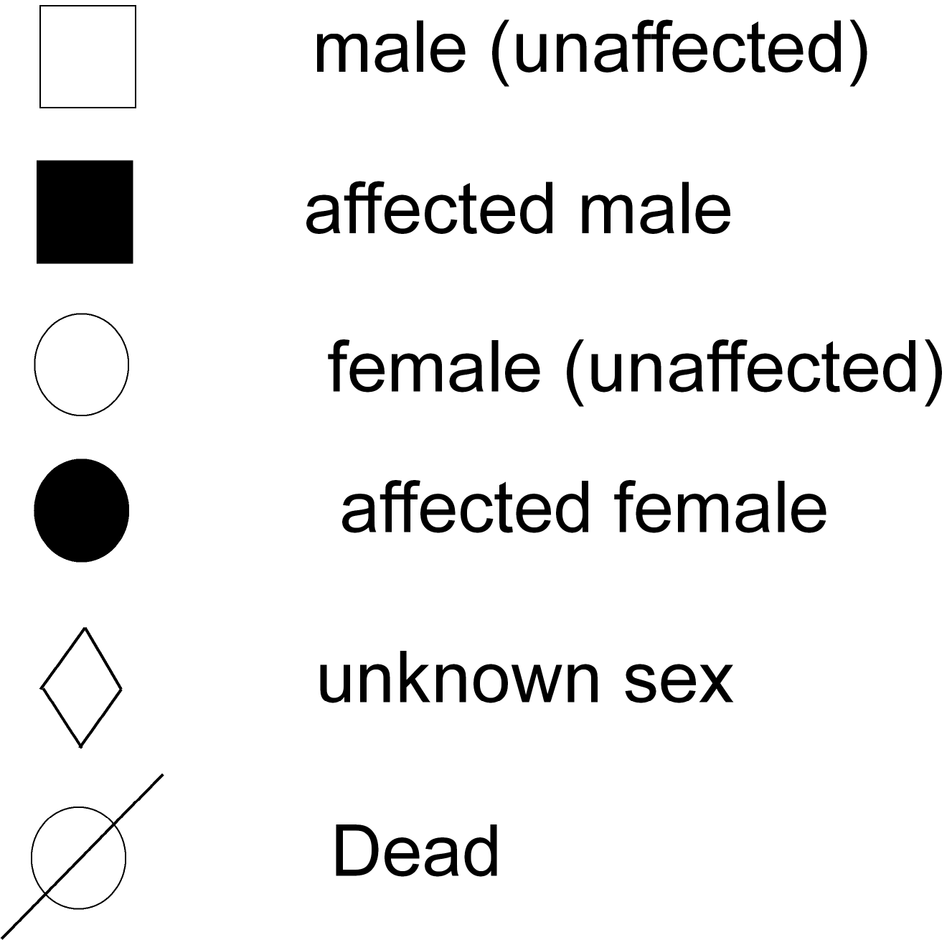
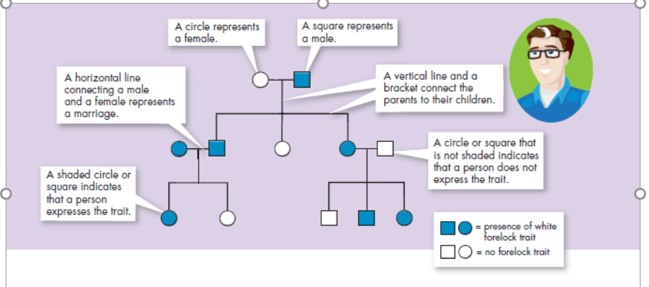
Example: Trait: Falconi anaemia
- The dominant form is normal bone marrow function - in other words, no anaemia.
- The recessive form is Falconi anaemia. Individuals affected show slow growth, heart defects, possible bone marrow failure and a high rate of leukemia.

A typical pedigree for a family that carries Falconi anemia.
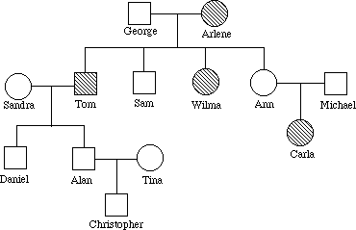

Ff

ff
Ff
Ff or FF

MUTATIONS:
Changes in the nucleotide sequence of DNA:
- May occur in somatic (body) cells (aren’t passed to offspring)
- May occur in gametes (eggs & sperm) and can be passed to offspring
Two ways in which DNA can be mutated:
- Mutations can be inherited.
- Mutations can be acquired (Environmental damage or mistakes when DNA is copied)
- Mutations may occur by exposure to MUTAGENS, which are mutation-causing agents
Examples:
- Radiation such as X-rays, Gamma rays, UV light
- Chemicals such as benzene, asbestos
Chromosome mutations:
May Involve:
  - Changing the structure of a chromosome
  - The loss or gain of part of a chromosome
Four types exist:
  - Deletion
  - Inversion
  - Duplication
  - Translocation

Example: Down Syndrome
  - Chromosome 21 does not separate correctly.
  - They have 47 chromosomes in stead of 46.
Gene Mutations:
May Involve:
  - Change in the nucleotide sequence of a gene
  - May only involve a single nucleotide
  - May be due to copying errors, chemicals, viruses, etc.
Three types exist:
  - Insertion
  - Substitution
  - Deletion

EVOLUTION:
- Evolution is the gradual development of different species from a common ancestor
- Natural Selection: Organisms that are best adapted to an environment survive and reproduce more than others
- Darwin’s Theory of Natural Selection occurs in four steps:
  - Overproduction
  - Variation
  - Competition
  - Selection
- Individuals with traits that are not well suited to their environment either die or leave few offspring.
- Evolution occurs when desired traits build up in a population over many generations and undesirable traits are eliminated by the death of the individuals.

EVIDENCE FOR EVOLUTION – key idea: evolution involves gradual changing of species (developing new species) over time from a common ancestor.
- Fossil Record - a record of the history of life on Earth; fossils of organisms that are a transition between extinct and current species show evidence of change in species over time
- Homologous Body Structures - similar anatomy in different types of animals because of common ancestor
- Vestigial Organs - “leftover” traces of structures that serve no purpose showing evidence of species changing over time.
- Embryology - embryos of all vertebrates are very similar early on suggesting a common ancestor
- Biochemical Evidence - DNA with more similar sequences suggests species are more closely related Eg: Humans and chimpanzees share more than 98% of identical DNA sequences. Closely related species suggest a common ancestor

